Key days
Stay informed about important deadlines and major milestones for RDPA 2025.
We look forward to welcoming you to RDPA 2025!

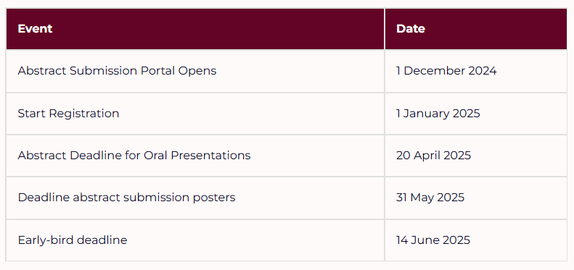

Only abstracts that are submitted by presenting authors who have registered for the congress within May 31st 2025 will be accepted.

Title (Arial 14)

A. Author1,^{1*} B. Author2,² C. Author3,¹ (Arial 12)
¹ Institution, Address, City, Country
² Institution, Address, City, Country
* Email: @

Text Text Text Text Text Text Text Text Text Text Text Text Text Text Text Text Text Text Text Text Text Text Text Text Text Text Text Text Text Text Text Text Text Text Text Text Text Text Text Text Text Text Text Text Text Text Text Text Text Text Text Text Text Text Text Text Text Text Text Text Text Text Text Text Text Text Text Text Text Text Text Text Text Text Text Text Text Text Text Text Text Text Text Text Text Text Text Text Text Text Text Text Text Text Text Text Text Text Text Text Text Text Text Text Text Text Text Text Text Text Text Text Text Text Text Text Text Text Text (Arial 11)
Reference number in square brackets after any punctuation.

Figure 1

Figure 1. text text text (Arial 11)

The abstract should be no longer than one page including figures and references.

References (Arial 10)
[1] Author, A.; Author, B. Abbreviated Journal Title Year, Volume, page–page
[2] Author, A.; Author, B.; Author, C. et al. Abbreviated Journal Title Year, Volume, page–page
[3] Author, A.; Author, B.; Author, C. et al. In Book Title; Editor, A., Ed.; Publishing House, Year; Vol. , page – page
[4] Author, A.; Author, B.; Author, C. et al. XY Patent no. , Year

